

**Hi my name is Gironimo**

**Let’s explore the opportunities in** **Lanciano**



|  |
| --- |
| ERASMUS IN LANCIANO |

SOME INFORMATIONS

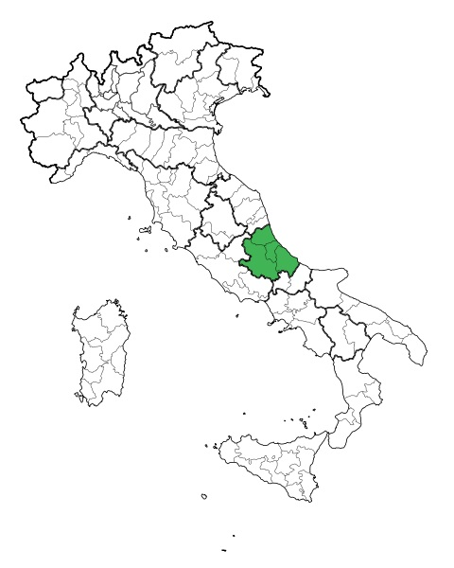

* **Lanciano is a beautiful medieval town with about 50 thousand inhabitants**
* **15 minutes from the sea**
* **45 minutes from Pescara**
* **50 minutes from the ski areas**
* **Meeting point for young people with shops, restaurants, pubs, pizzerias**

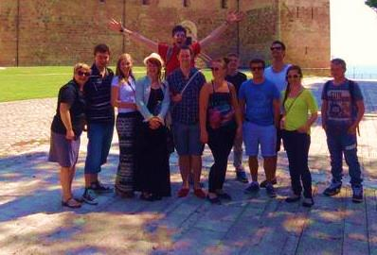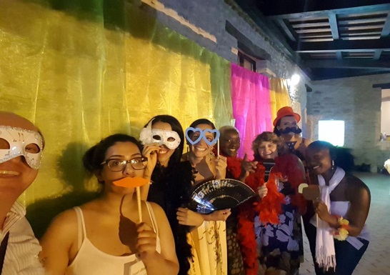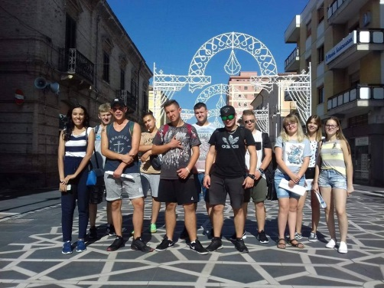

+39 0872- 43298

WWW.CONNECTABRUZZO.IT



|  |
| --- |
| ERASMUS IN LANCIANO |

ACCOMODATION

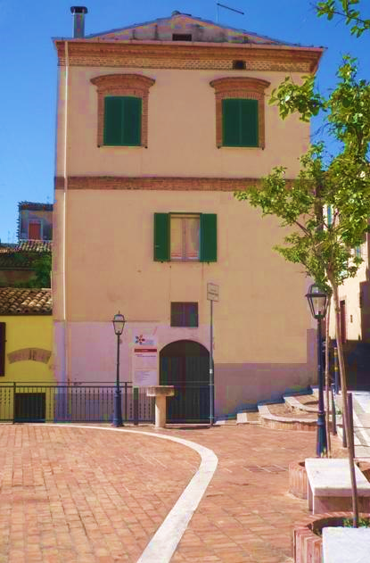Z

* **Palazzo Lupini is located in the center 500 meters from the main square**
* **4 bedrooms, 3 bathrooms and sleeps 10**
* **WiFi, dishwasher, washing machine**



**This is your house!!!   
  
You can walk anywhere in the city**

+39 0872- 43298

WWW.CONNECTABRUZZO.IT

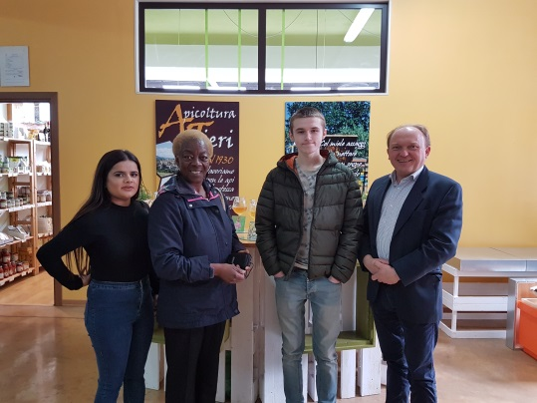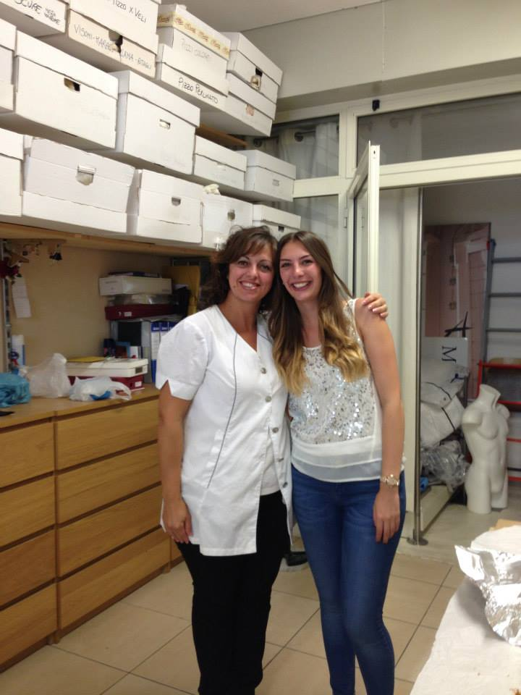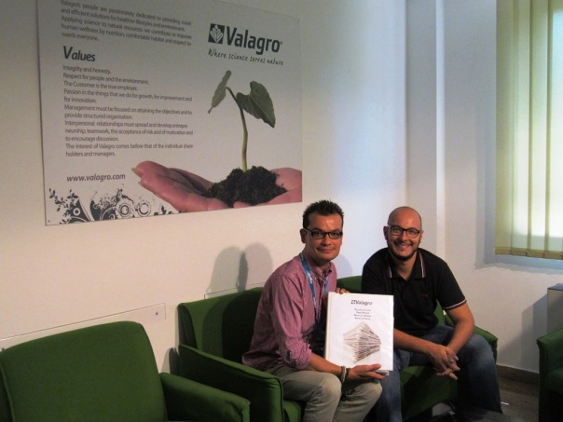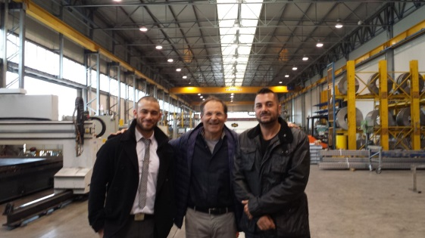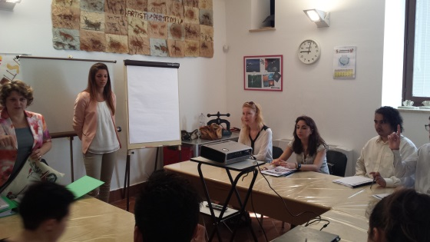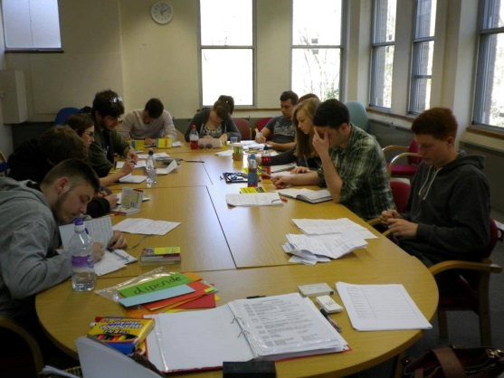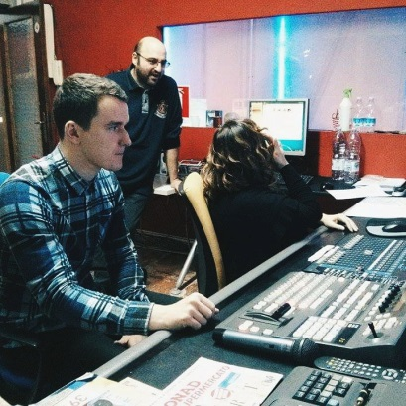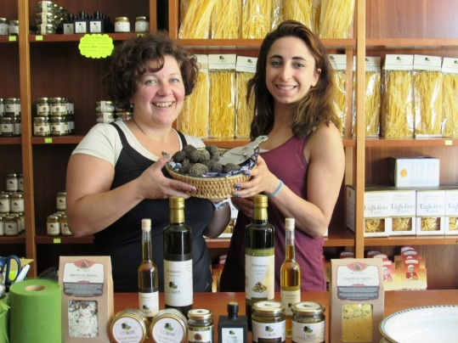

**Hard but nice work!!!**



+39 0872- 43298

AT WORK

**ERASMUS IN LANCIANO**

…AND MORE



**Friends, trips and adventures**



|  |
| --- |
| ERASMUS IN LANCIANO |

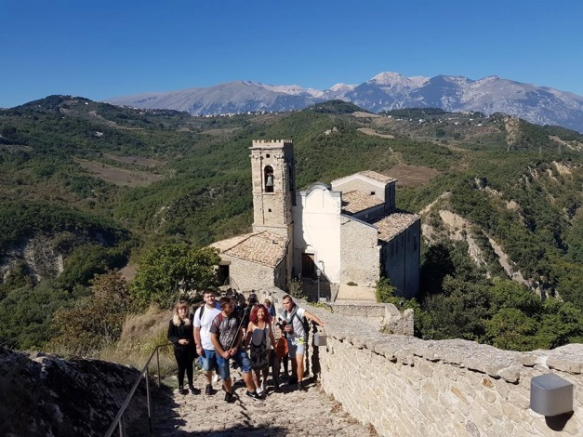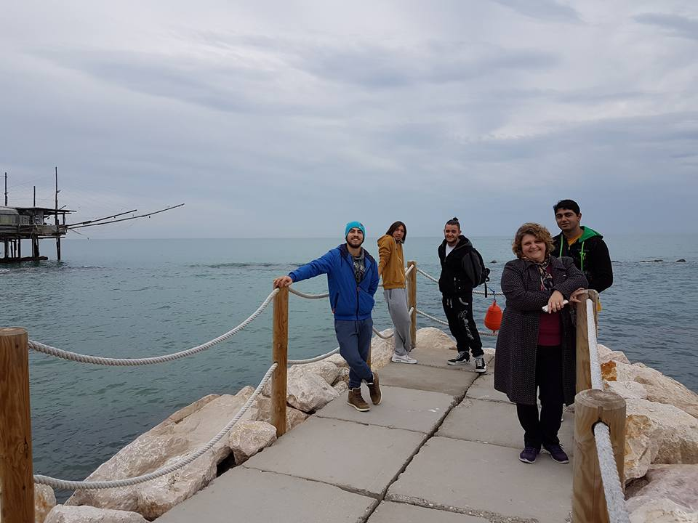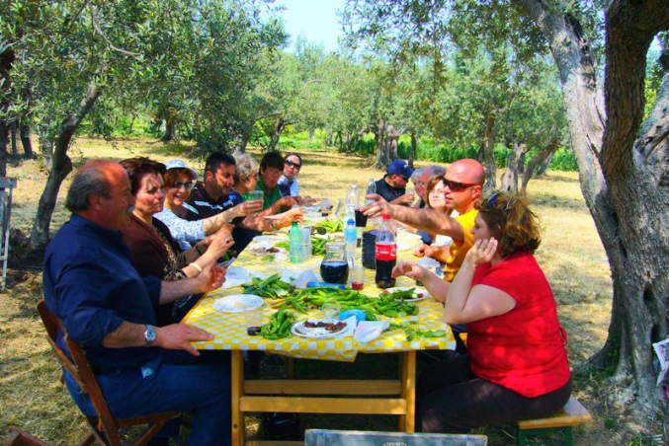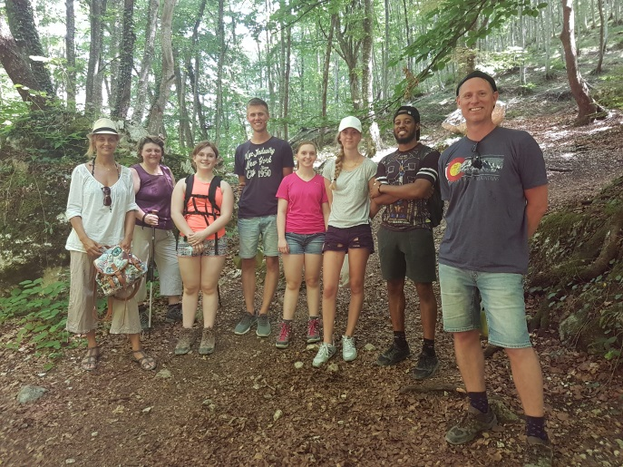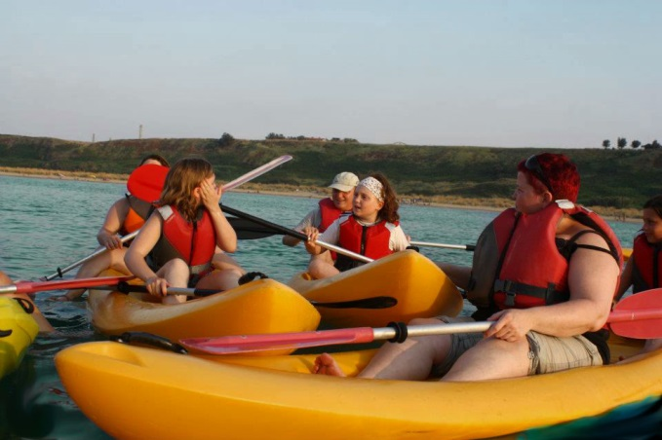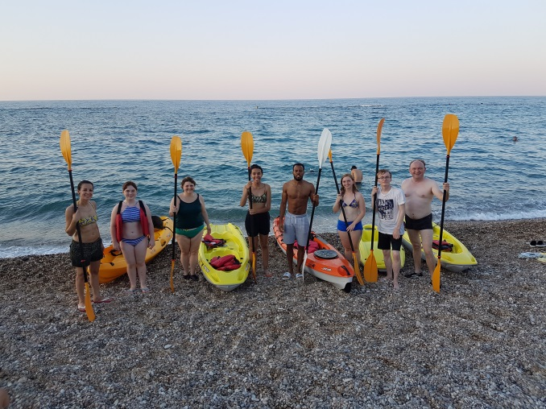

+39 0872- 43298

THINKS TO DO